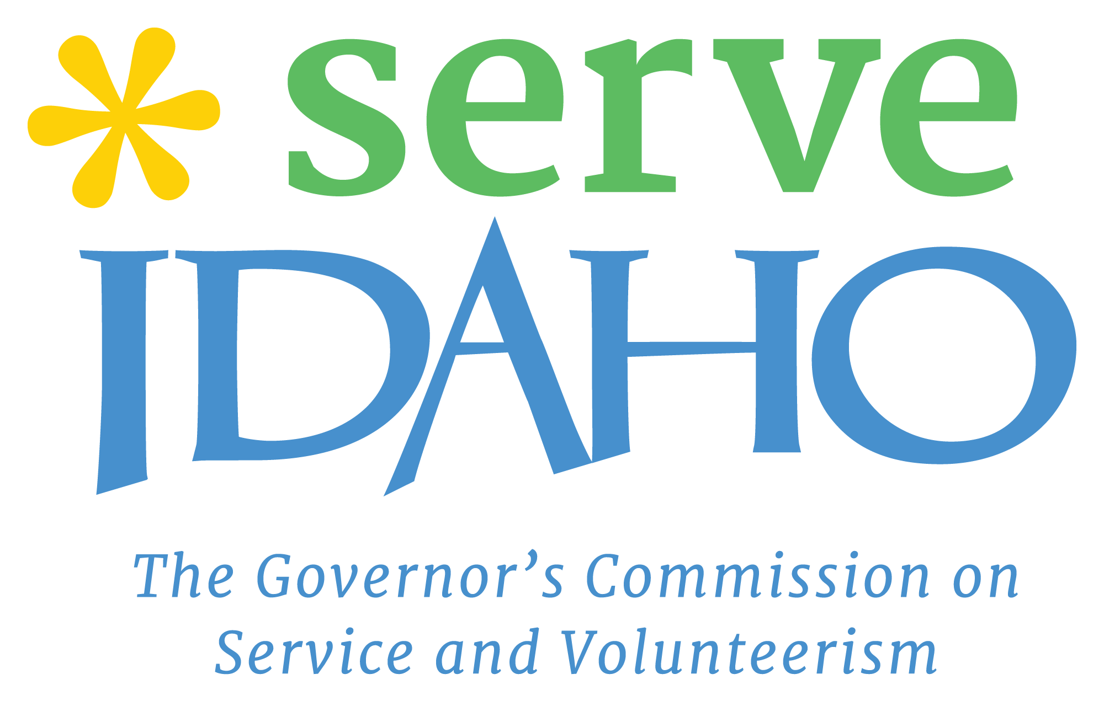 Community Development AmeriCorps VISTA
Serve Idaho, the Governor’s Commission on Service and Volunteerism
Help us build a better Idaho through service and volunteerism! As Serve Idaho’s Volunteer in Service to America (VISTA) member you will identify the greatest needs of Idaho’s rural nonprofits and lead efforts to build a statewide support structure.

Program Description
Serve Idaho, the Governor’s Commission on Service and Volunteerism is a statewide government organization located in beautiful downtown Boise, ID, just steps away from Idaho’s best trails, rivers, and restaurants. Established in 1993, we are dedicated to supporting communities and nonprofits across the state through volunteerism. Serve Idaho is made up of a dynamic team of smart and creative professionals that see volunteerism and community empowerment as a solution to Idaho’s most pressing issues.
We are looking for a dedicated individual to spearhead efforts to develop a model to support Idaho’s rural nonprofits through VISTA service. Service will include convening community partners to identify the greatest needs, researching existing structures, and recruiting VISTA host sites.
The ideal candidate would have a passion for building new systems, strong public speaking skills, comfort in leading meetings, ability to collaborate with stakeholders and a knowledge of Idaho’s rural communities.
Members serving with Serve Idaho will join a team of professionals who are passionate about service and volunteerism and see the value in using service to solve Idaho’s unmet needs. The member will build their professional network, working alongside community leaders and Governor appointed commissioners. They will receive extensive professional development opportunities and monthly training. Serve Idaho promotes professional development, team learning, and a strong work/life balance.
This year long position will start July 6, 2021 and may be available as a teleservice position. Please submit your resume and cover letter to Renee Bade at renee.bade@labor.idaho.gov OR apply via the AmeriCorps portal at by the close of business Monday May 24. Questions about the position can also be directed to Renee Bade at renee.bade@labor.idaho.gov.

Member Duties
The VISTA member will spearhead efforts to identify the greatest needs of Idaho’s rural nonprofits and lead implementation of a statewide program to support Idaho’s nonprofits through the development of an AmeriCorps VISTA intermediary model. Duties will include: Convening community partners and rural nonprofits to assess greatest statewide needs; Conduct interviews/develop surveys to identify the barriers and successes of rural nonprofits; Research existing models to expand national service and volunteerism in Idaho.

Program Benefits: Relocation allowance, training, Health Coverage*, Childcare assistance as eligible, Choice of education award or end of service stipend, professional development, living allowance of $513.94/bi-weekly, free downtown parking, Federal noncompetitive eligibility, student loan forbearance and deferment.
- For details about AmeriCorps healthcare benefits please visit http://www.vistacampus.gov/healthcare.

Terms:
18 years old; US citizen, national or legal resident; Successfully complete a criminal background check; Valid Driver’s License Ability to serve 40/hours a week; Car recommended; Permits attendance at school during off hours; Ability to telework as necessary due to COVID 19 restrictions

