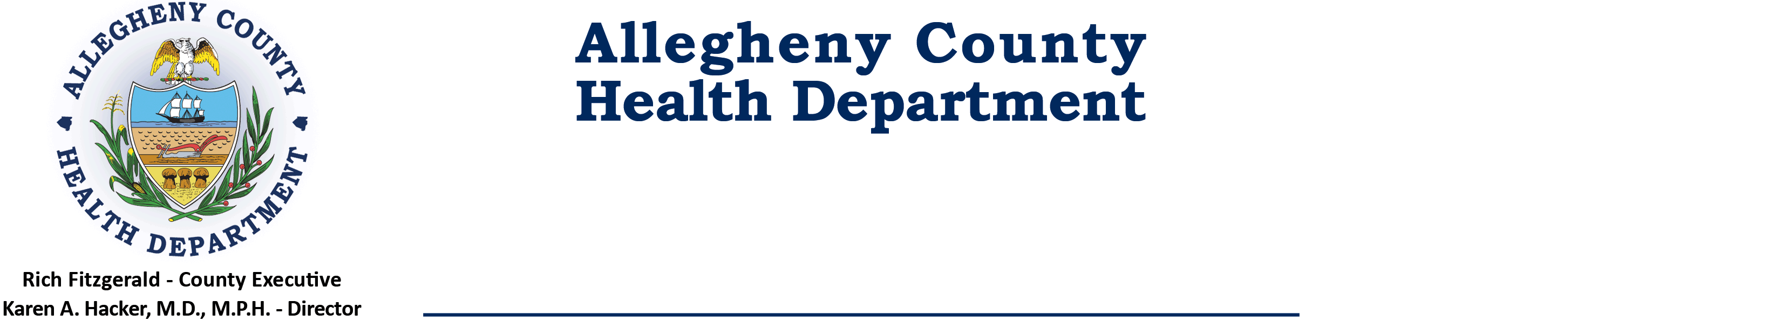
Air Quality Program
301 39th Street, Clack Health Center Building 7, Pittsburgh, PA 15201-1811
Phone: 412.578.8103 • Fax: 412.578.8144 • 24-Hr. 412.687.ACHD (2243)

January 11, 2022

To: ACHD Air Regulation Subcommittee Members & Attendees

From: Tom Lattner, Subcommittee Liaison

Subject: ACHD Air Regulation Subcommittee Meeting Agenda

Please be advised that a Regulation Subcommittee meeting has been scheduled for:

Via Microsoft Teams

Tuesday, January 18, 2022

1:30 p.m.

__________________________________________________________________________

AGENDA

1. Introductions (see Note)

2. Review of Regulations in Progress/Status Table

3. Review of proposed SIP-94 - Revision to Article XXI: The addition of Section 2105.87, “Control of VOC Emissions from Oil and Natural Gas Sources.”

4. Review of 2nd Draft of revisions to Article XXI §2105.21, ‘Coke Ovens and Coke Oven Gas,’ and related §2101.20, ‘Definitions,’ and §2109.01, ‘Inspections’. (SIP87).

5. Other regulations anticipated to be on the Subcommittee’s 2022 agendas. (At Chair’s request.)

6. Other Business

CC: Interested Parties

NOTE: This will be a virtual meeting using Microsoft Teams.
Microsoft Teams meeting
Join on your computer or mobile app
Click here to join the meeting
Or call in (audio only)
+1 267-368-7515,,83425869# United States, Philadelphia
Phone Conference ID: 834 258 69#

